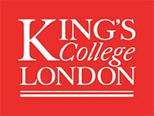

Feedback from previous Flexible Supplement Applications – Review Panel:
To support students in submitting successful Flexible Supplement applications, the MRC DTP Team have complied a record of general feedback from the review panel.

‘Applications must have a thorough break down of costings in the application; we need to understand the specifics of the funding request’.
‘Applications which clearly explain how an opportunity, training course, or piece of equipment (not exhaustive) is relevant to their PhD are more persuasive as this demonstrates the applicant has clearly thought through their request’.
‘The strongest applications convey why the request is important to their PhD’
‘Strong applications detail the skill set which will be acquired as a result of the funding’.
‘If funding is requested for a new piece of equipment, we want to understand where this equipment will be hosted at King’s and we need to see that there is support for the student to learn to use the equipment’.
‘Applications must include details of all supporting sources of income; if there is additional funding available we would like to know the total amount available and where this funding is from’
‘Students must read the parameters of the funding carefully – this is clearly detailed in the application form’

